Raffles Institution (Junior College)
2009 Preliminary Examination H2 Chemistry
Suggested Solutions

Question 1
(a)(i) Amount of lactic acid = Amount of NaOH needed for neutralisation
= 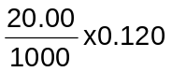= 0.0024 mol
Concentration of lactic acid = 0.0024 ÷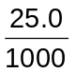= 0.0960 mol dm⁻³

(ii) pK_{a} = pH at half-neutralisation = 3.85 (when V_{NaOH} = 10 cm³)
K_{a} = 10^{−3.85} = 1.41 x 10⁻⁴ mol dm⁻³
Alternatively, K_{a} = 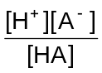
Initially, [H⁺] = [A⁻] = 10^{−2.45} = 3.548 x 10⁻³ mol dm⁻³
K_{a} = 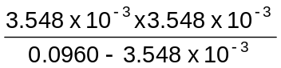= 1.36 x 10⁻⁴ mol dm⁻³ where HA = lactic acid

(iii) At equivalence point, the resultant mixture is a solution of sodium lactate, H₃CH(OH)COO⁻Na⁺.
Being the conjugate base of a weak acid, lactate ion hydrolyses in water to give OH⁻:
CH₃CH(OH)COO⁻(aq) + H₂O(l) ⇌ CH₃CH(OH)COOH(aq) + OH⁻(aq)
The formation of OH⁻ causes the pH at equivalence point to be greater than 7.
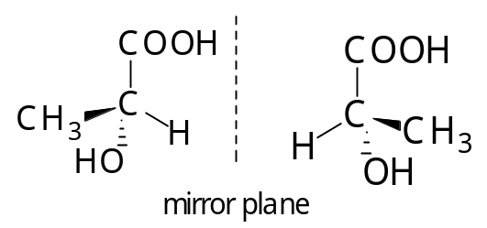
(b)(i)

Samples A and B contain lactic acid but the lactic acid in B is the enantiomer/ optical isomer of the lactic acid in A. Hence A and B behave differently towards plane−polarised light.

(ii) Sample C is a racemic mixture of the two optical isomers of lactic acid (contains equal amounts of the two optical isomers of lactic acid) and hence does not exhibit optical activity.
Due to the mixture of the optical isomers, the packing of lactic acid molecules in C is not as regular as the packing of lactic acid molecules in A where only one optical isomer of lactic acid is present.
Hence melting point of sample C is lower than that of A.
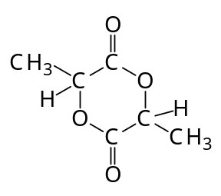
- Compound D is

D does not contain −OH nor −COOH since it does not react with sodium.
It is a diester formed when −OH and −COOH groups of one lactic acid molecule reacts with the −COOH and −OH groups respectively of another lactic acid molecule.
(d)(i) E has a chiral centre as it rotates plane−polarised light.
E is an aldehyde since it reacts with Fehling’s solution to give a reddish brown precipitate.
Amount of hydrogen evolved with sodium per mol of E = 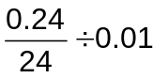 = 1 mol
Hence two displaceable H are present ⇒ there are two −OH group.
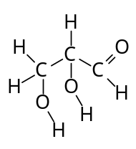

E is

(ii) E is an alcohol. The stability of its anion is lower than the stability of the anion of lactic acid as the anion is destabilised by the electron−donating −CH₂CH(OH)CHO group.
Lactic acid is a much stronger acid as its anion forms two equivalent resonance structures with the negative charge on O delocalised over two electronegative O atoms.
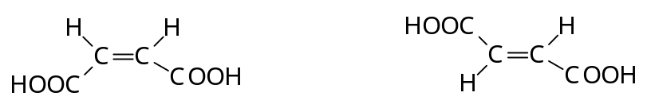
(e)(i)

maleic acid fumaric acid

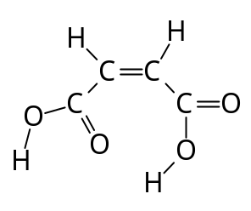
(ii) Intramolecular hydrogen−bonding occurs in maleic acid and thus it has lower melting point as there are less sites for inter−molecular hydrogen bonding.

••
δ−

intra−molecular hydrogen bond
δ+

Question 2
(a)(i) Heat evolved = 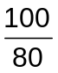x 200 x 4.18 x 46.9 J = 49.01 kJ
Amount of cyclobutane used = 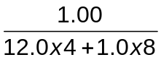= 0.01786 mol

ΔH_{c}[] = −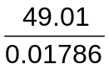= −2.7446 x 10³ kJ mol⁻¹ = −2.74 x 10³ kJ mol⁻¹

(ii) ΔH₁ = ΔH_{C}[] − 2ΔH_{C}[CH₂=CH₂] = −2.745 x 10³ − 2(−1422) = +99 kJ mol⁻¹

(iii) ΔS of the reaction is greater than 0 since more gaseous molecules are formed in the forward reaction.
ΔH is greater than 0
To be spontaneous, ΔG = ΔH − TΔS < 0 ⇒ ΔG likely to be negative if T is large.
Hence reaction is favoured by high temperature.

(b)(i) Bond energy of X−Y bond is the average energy absorbed when 1 mol of X−Y bonds are broken in gaseous state.
(ii) ΔH₁ = Σ(bonds broken) − Σ(bonds formed)
+99 = 4BE(C−C) + 8BE(C−H) − [2BE(C=C) + 8BE(C−H)]
= 4BE(C−C) − 2 x 610
BE(C−C) = ¼(99+1220) = 330 kJ mol⁻¹

(iii) The C−C−C bond angle in cyclobutane is 90º which is much smaller than the normal sp³ −hybridised angle of 109º. [1]
The angle strain weakens the C−C bond in cyclobutane so that it is lower than the C−C bond energy value (which is the average of C−C bond energy found in compounds) found in the Data Booklet.

(c)(i) To keep the total volume constant so that the concentration of ethene or bromine used is directly proportional to the volume used.

(ii) Rate of reaction is inversely proportional to the time taken for the colour of bromine to disappear
and directly proportional to the volume of bromine used.

(iii) Rate ∝ 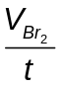
Comparing experiments 1 and 2,
[ethene] used in experiment 2 is decreased to 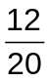=0.6 x [ethene] used in expt 1.
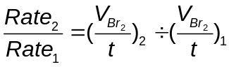= 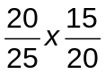 = 0.6
Since a decrease in [ethene] results in the same decrease in rate, the reaction is first order with respect to ethene.

Comparing experiment 1 and 3,
[Br₂] used in experiment 3 is decreased by 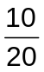=0.5 x [Br₂] used in expt 1
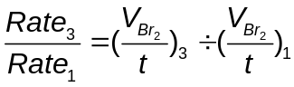= 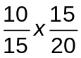 = 0.5
Since a decrease in [Br₂] results in the same decrease in rate, the reaction is first order with respect to bromine.

(iv) 15 s
(v) The reaction progresses via electrophilic addition mechanism with the formation of carbocation, CH₂BrCH₂⁺.
Subsequent addition of CH₃OH to the carbocation and loss of H⁺ results in the formation of product as shown:
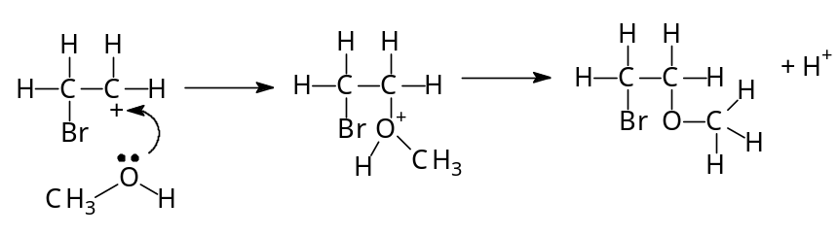

(displayed formula of C₃H₇OBr)

Question 3
(a) The electronic configuration of V³⁺ is [Ar]3d².
Hence its 3d−subshell is only partially filled.
V³⁺ exists as aqua complex, [V(H₂O₆)]³⁺ in aqueous solution.
H₂O ligand splits the 3d−subshell into two sets of different energy.
Electron in the lower set absorbs visible light energy corresponding to the small energy gap between the 2 sets of energy and is promoted to the upper set.
Since visible light is absorbed, aqueous solutions of vanadium ions are coloured, with the colour observed being the complementary colour of the light absorbed.

(b)(i) SO₂ (g) + 2VO₂⁺ (aq) ⎯→ SO₄²⁻ (aq) + 2VO²⁺ (aq)
SO₂ reduces yellow VO₂⁺ to blue VO²⁺.
As the reaction proceeds, the presence of both yellow VO₂⁺ and blue VO²⁺ causes the mixture to appear green until all VO₂⁺ is used up and the solution appears blue due to VO²⁺.

(ii) SO₂ can also react with KMnO₄. It must be boiled off completely to ensure that none of it remains so that the KMnO₄ used in titration reacts only with vanadium ions and hence the amount of vanadium ions can then be determined accurately.

(iii) Amount of vanadium ions = 5 x amount of MnO₄⁻ used
= 5 x 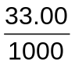x 0.0200 = 3.300 x 10⁻³ mol
Mass of vanadium in sample = 3.300 x 10⁻³ x A_{r} of V = 3.300 x 10⁻³ x 50.9 = 0.1680 g
Percentage by mass of V = 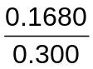x 100 = 56.0%

(c)(i) Reaction at electrode A:
VO₂⁺(aq) + 2H⁺(aq) + e⁻ ⎯→ VO²⁺ (aq) + H₂O (l)
Reaction at electrode B:
V²⁺(aq) ⎯→ V³⁺ (aq) + e⁻
E^{O}_{cell} = 1.00 − (−0.26) = +1.26V

(ii) Electrode A is the positive electrode as electrons are consumed in the reaction due to reduction of VO₂⁺ to VO²⁺.

(iii) To increase the total surface area of the electrodes so that the reactions at the electrodes proceed rapidly.

(iv) As the reaction proceeds, the electrolyte in tank A becomes increasingly negative (due to consumption of H⁺) while the electrolyte in tank B becomes increasingly positive (due to a more highly positively charged ion being formed).
The membrane allows selective ions to pass through (eg H⁺ to migrate via membrane from tanks B to A) to maintain electrical neutrality.

(v) Spent electrolyte may be replaced by fresh electrolyte so that the battery does not run out of power.
(Other acceptable answers: Storage of chemicals in conventional battery lead to loss of power/ environment aspect due to battery being thrown away etc.)

(d) VO₂⁺(aq) + 2H⁺(aq) + e⁻ ⎯→ VO²⁺ (aq) + H₂O (l)
Change in amount of VO₂⁺ required = (0.90−0.10) x 3 x 2.00 mol = 4.80 mol
Amount of electrons needed = 4.80 mol
Quantity of electricity required = 4.80 x 96500 C = 4.632 x 10⁵ C
Time required = 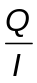s = 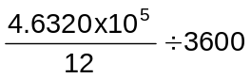h = 10.7 h

Question 4
(a) Iodine oxidises thiosulfate to tetrathionate resulting in a change of average oxidation number from +2 to +2.5:
I₂ + 2S₂O₃²⁻ ⎯→ 2I⁻ + S₄O₆²⁻
Chlorine oxidises thiosulfate to sulfate(VI) resulting in a change of average oxidation number from +2 to +6:
4Cl₂ + S₂O₃²⁻ + 5H₂O ⎯→ 8Cl⁻ + 2SO₄²⁻ +10H⁺
Since chlorine is able to increase the oxidation state of S in thiosulfate more greatly than iodine, chlorine has higher oxidising power than iodine.

(b)(i) NaCl(s) + H₂SO₄(l) ⎯→ NaHSO₄(s) + HCl(g)

(ii) Hydrogen iodide formed is oxidised by conc H₂SO₄ to iodine since HI is easily oxidised.

(iii) Concentrated phosphoric(V) acid.
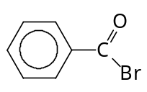
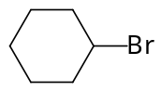
(c)

reacts with aq NaOH at room temperature, reacts with aq NaOH only on warming.
This is because C₆H₅COBr undergoes nucleophilic substitution more readily than C₆H₁₁Br which requires heating for the reaction with aq NaOH to form C₆H₁₁OH. C₆H₅Br does not react with aq NaOH.
Their differences in reaction with aq NaOH is due to differences in structures which result in different ease of substitution.
Due to the presence of electronegative O attached to the carbonyl C, the carbonyl C in C₆H₅COBr is more partially positive compared to the C to which Br is attached in C₆H₁₁Br.
The carbonyl carbon in C₆H₅COBr is also sp²−hybridised so that it is less sterically hindered than the sp³−hybridised carbon to which the Br atom is attached in C₆H₁₁Br.
Due to the overlap of the orbital containing lone−pair of electrons on Br with π−electron cloud of benzene ring, the C−Br has partial double bond character so that it is not easily broken and does not react with aq NaOH even on heating.

(d)(i) Ca has a bigger atomic radius/ more diffuse electron cloud than Mg so that it does not form strong covalent bond with R and X. Thus, it is not able to form organometallic compounds with halogenoalkanes.
Lithium/ copper gives a similar reaction with halogenoalkane as magnesium.
(ii) Being a very strong base, R in RMgX reacts with water to form an alkane, RH which would prevent it from acting as a nucleophile.
(iii) The reaction between Mg and RX requires breaking of the C−X bond.
C−X bond gets weaker in the order C−F > C−Cl > C−Br > C−I due to decrease in efficiency of overlap of C and X orbitals as valence orbital of X becomes more diffuse as halogen increases in size/ decrease in polarity of C−X bond as X decreases in electronegativity down the group.
Hence reactivity between RX and Mg is in the order: iodoalkane > bromoalkane> chloroalkane > fluoroalkane.
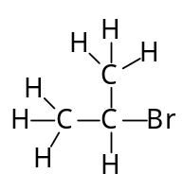
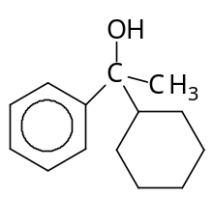
(iv) (v)

(displayed formula)

(vi) One mole of RMgBr reacts with one mole of CH₃COBr via nucleophilic substitution mechanism to form one mole of the ketone CH₃COR. The one mole of CH₃COR formed then reacts with another mole of RMgBr to form CH₃CR₂OH.

(vii) Ratio of alcohol A: alcohol B: alcohol C
= 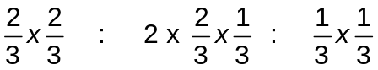
= 4 : 4 : 1

Question 5
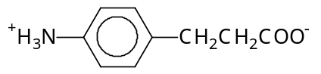
(a)(i) F exists as zwitterions so that ionic bonds hold the zwitterions strongly,

resulting in it having higher melting point than D which only has weaker hydrogen bonds between its molecules.
D is basic and does not react with aq NaOH. It can only interact with water molecules in NaOH(aq) via hydrogen bonding. The hydrophobic benzene ring further limits its solubiliity in aq NaOH.
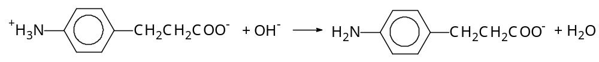
F is amphoteric and hence reacts with aq NaOH to form an anion:

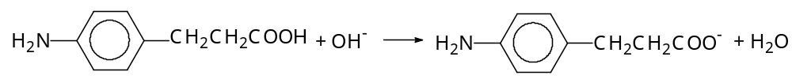
Or

The anion interacts with water molecules strongly via ion−dipole interactions so that F is more soluble in NaOH(aq) than D.
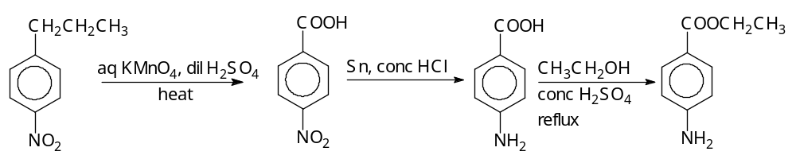
(ii)

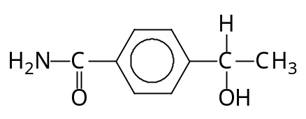
(iii)
Or other sensible answers (presence of
CH₃CHOH− or CH₃CO− group and absence
of amine and −COOH groups.)

(b) | Information | Deduction of structure
 | Formula of G = C₈H₁₁O₃N | Index of unsaturation  = ½( 2x8+2−11+1) = 4  (or high C to H ratio)  ⇒ G is likely to contain a benzene ring/ aromatic.
 | G rotates plane−polarised light. | G is likely to contain at least one chiral carbon.
 | G gives a violet colouration with neutral FeCl₃ solution | G is a phenol with violet colourtion formed by complex formation.
 | G reacts with 2 mol of aq NaOH | There are 2 phenolic−OH group in G, reacting with OH⁻ via acid-base reaction.
 | G is insoluble in water but dissolves in dil H₂SO₄. | G is likely to contain an amine group, with −NH₂ being protonated by H⁺.
 | G is oxidised by K₂Cr₂O₇ to form a product which reacts with 2,4−DNPH to give an orange ppt. | G is a secondary alcohol and is oxidised to a ketone by K₂Cr₂O₇.
 | H is formed by reaction of G with Al₂O₃ | H is formed from G by dehydration, it is likely an alkene.
 | H reacts with aq Br₂ to form C₈H₇O₃NBr₄. | The product is likely to be a bromohydrin formed by electrophilic addition and electrophilic substitution into activated benzene ring.
 | G reacts with CCO−COC to form J which has 3 hexagonal rings. | The phenol, secondary alcohol and amine reacts with CCO−COC via nucleophilic substitution.  3 hexagonal ring ⇒ cyclic esters and amides formed with the phenolic −OHs and alcoholic−OH and amine on adjacent carbon atoms.
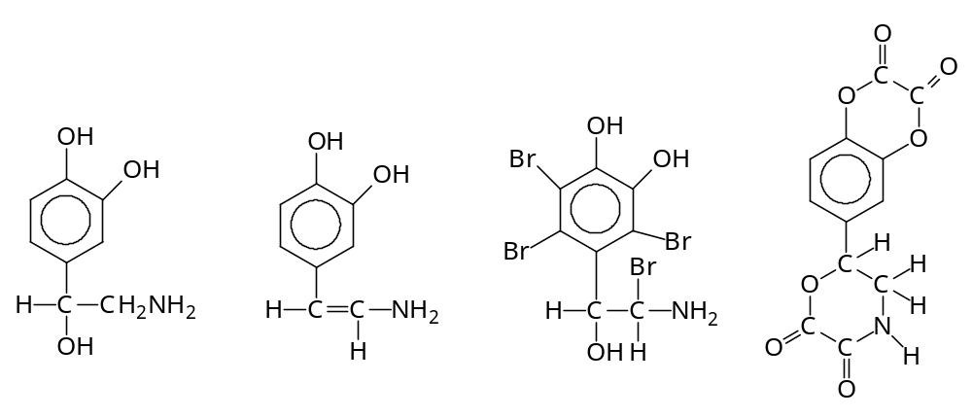

*

G H J

